Chapter 3, Problem 46.

Calculate the mesh currents i₁ and i₂ in Fig. 3.92.

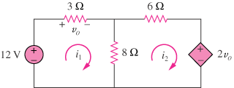

Figure 3.92
For Prob. 3.46.

